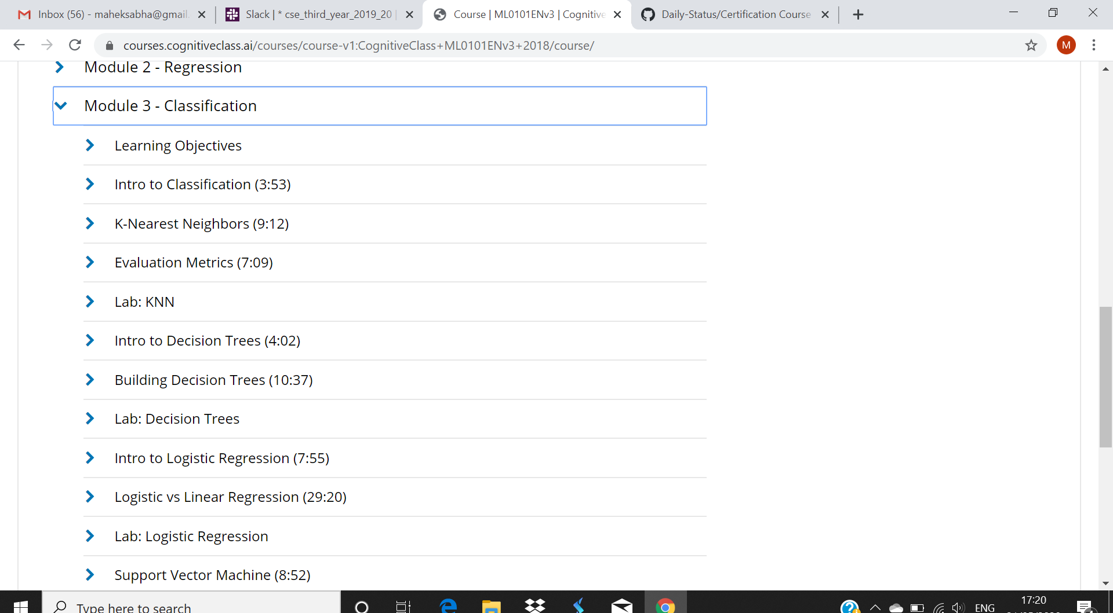

Completed with module 3:

I have taken up a test based on some topic related to machine learning in module 3

